READING READINESS  This is not a reading programme but rather one that will get them ready for reading far more easily in Grade 1. It lays a firm foundation for learning later in life. It is a specific series of lessons that works with any phonics programmes such as Letterland, Thrass or Jolly Phonics. | Neuro Dynamix  Growing research proves that children move less for various reasons which creates barriers to learning. It is a unique programme that rewires the neuro pathways to the brain using specific movements targeting the senses, the vestibular system, proprioception and Kinesis. It is done in Collaberation, with the Mind Moves Institute. | “Children Moving Purposely makes positive contributions to Knowledge of self and the environment”  Jack Capon | s  Remedial Centre  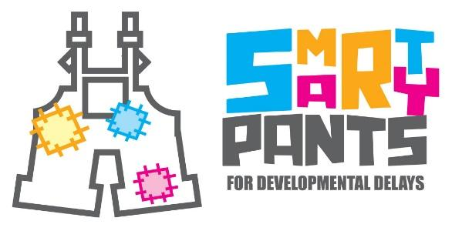
 | Dyslexia Early screening  Research has shown that the earlier children with potential reading difficulties are identified, the easier it is to overcome their reading problems.  DEST – 2 is a test designed fortteachers. It forms a valuable step in deciding whether to refer a child for further testing | 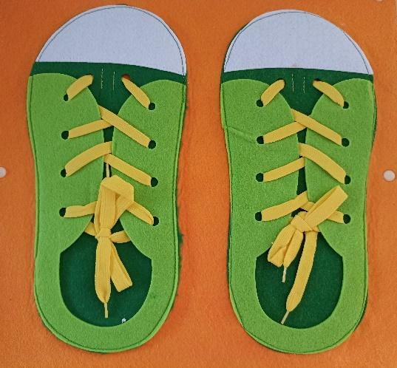 | 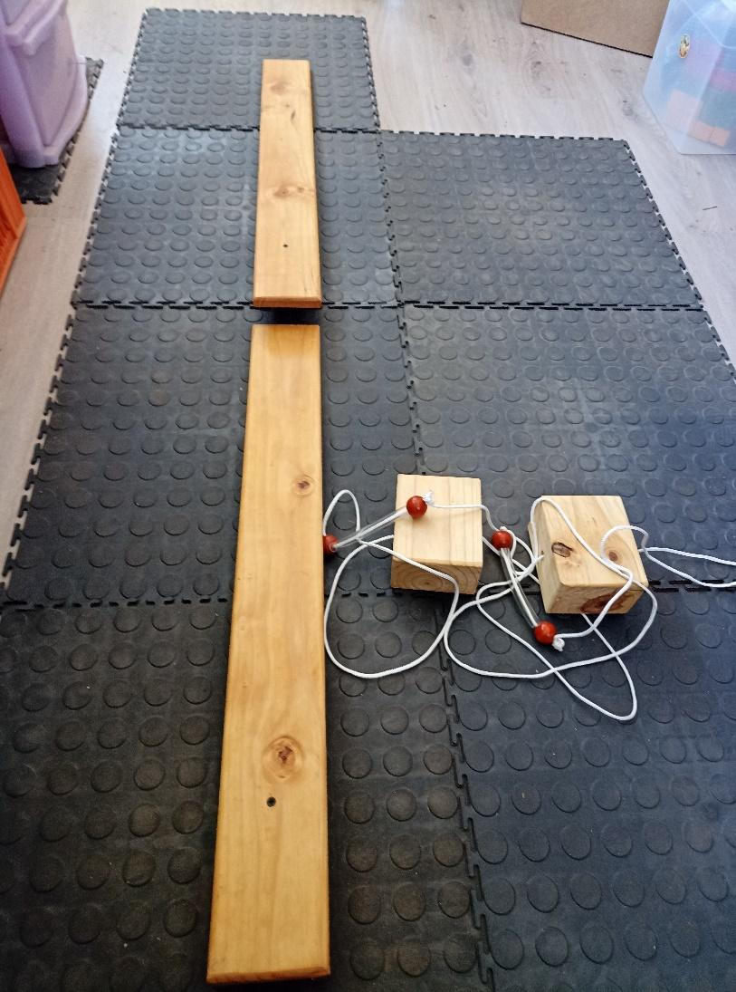  94
 | 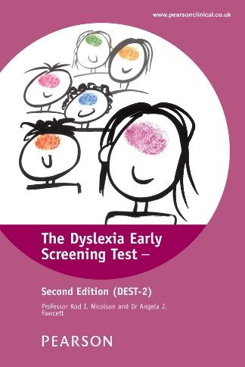 | Smarty Pants  •••  667 Jocelyn Street  Shelly Beach  •••  Jacky 064 653 0128  •••  Smartypantslearninghub@gmail.com  •••

School Readiness Assessment  If your child is struggling in Grade R and you are unsure of letting him/her repeat the year. Let me do a School Readiness assessment. I am unbiased and will give a truthful and independent assessment, pinpointing exactly where the weak areas of his/her development are.  You will receive a written report that you can take to the school. | October Specials  Grade 1 School Readiness Assessment: R350  Normal Price: R500  Dyslexia Early Screening: R250  Normal Price R450 | Weekdays  8:30-5:00pm  667 Jocelyn Street  If you, as a parent, feel overwhelmed, let me help you. With over 40 years of Teaching experience, I can help your child overcome the Barriers to Learning. |  | 
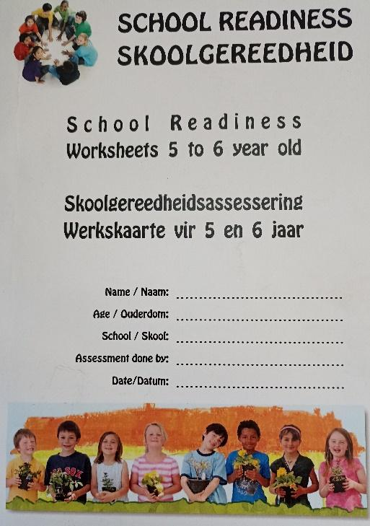 | GRADE R MID-YEAR ASSESSMENT  If you need to know in which area of development your child is struggling, I can do a mid-year assessment (May) to help guide you in the right direction. It will cover all the aspects of his/her development which are: emotional, social, physical and cognitive.  You will receive a written report. |  |  | “To provide a safe and nurturing environment in which each learner can flourish. Furthermore, our mission is to educate the learners on their functional and instruction-level and not on their frustration level “
 | 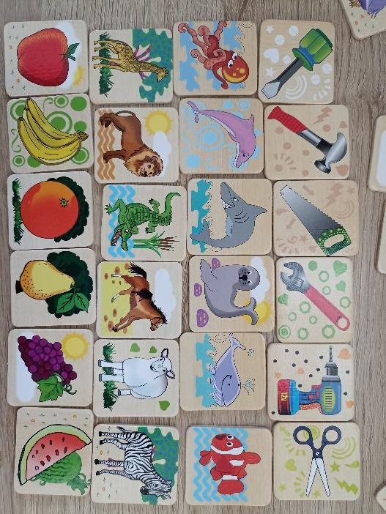 |  | Remedial  From 4 years old to Matric.  Anything I can add here??? | 

